Lab 2

Activity 6

using System;

using System.Collections.Generic;

using System.ComponentModel;

using System.Data;

using System.Drawing;

using System.Linq;

using System.Text;

using System.Threading.Tasks;

using System.Windows.Forms;

namespace WindowsFormsApplication14

{

public partial class Form1 : Form

{

// private object lblSeason;

public Form1()

{

InitializeComponent();

}

private void btnSeason_Click(object sender, EventArgs e)

{

int Month = Convert.ToInt32(txtMonth.Text);

if (Month == 12 || Month >= 1 && Month <= 3)

{

lblseason.Text = "WINTER";

}

else if (Month >= 4 && Month <= 6)

{

lblseason.Text = "SUMMER";

}

else if (Month >= 7 && Month <= 9)

{

lblseason.Text = "SPRING";

}

else if (Month == 10 || Month == 11)

{

lblseason.Text = "AUTUMN";

}

}

private void txtMonth_TextChanged(object sender, EventArgs e)

{

}

private void Form1_Load(object sender, EventArgs e)

{

}

private void lblMonth_Click(object sender, EventArgs e)

{

}

private void lblseason_Click(object sender, EventArgs e)

{

}

}

}

**Output**

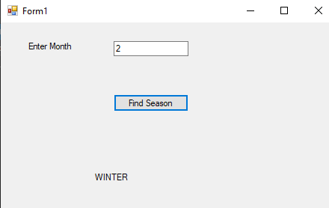

Activity 7

using System;

using System.Collections.Generic;

using System.ComponentModel;

using System.Data;

using System.Drawing;

using System.Linq;

using System.Text;

using System.Threading.Tasks;

using System.Windows.Forms;

namespace WindowsFormsApplication15

{

public partial class Form1 : Form

{

public Form1()

{

InitializeComponent();

}

private void lblBill_Click(object sender, EventArgs e)

{

}

private void txtUnits_TextChanged(object sender, EventArgs e)

{

}

private void btnCalculateBill_Click(object sender, EventArgs e)

{

int units = Convert.ToInt32(txtUnits.Text);

int bill = 0;

if (units >= 1 && units <= 100)

{

bill = units * 2;

lblBill.Text = "Rs" + bill.ToString();

}

else if (units > 100 && units <= 200)

{

bill = 200 + ((units - 100) * 3);

lblBill.Text = "Rs" + bill.ToString();

}

else if (units > 200 && units <= 300)

{

bill = 200 + 300 + ((units - 200) * 4);

lblBill.Text = "Rs" + bill.ToString();

}

else if (units > 300 && units <= 400)

{

bill = 200 + 300 + 400 + ((units - 100) * 7);

lblBill.Text = "Rs" + bill.ToString();

}

else if (units > 400)

{

int i = 9;

units = units - 400;

while (units > 100)

{

bill = 100 * i;

units = units - 100;

i = i + 2;

}

bill = bill + (units * i);

bill = bill + 200 + 300 + 400 + 700;

lblBill.Text = "Rs" + bill.ToString();

}

}

}

}

output

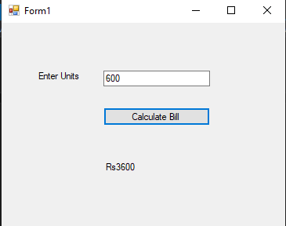

Acyivity 8

using System;

using System.Collections.Generic;

using System.ComponentModel;

using System.Data;

using System.Drawing;

using System.Linq;

using System.Text;

using System.Threading.Tasks;

using System.Windows.Forms;

namespace DemoApp

{

public partial class Form1 : Form

{

public Form1()

{

InitializeComponent();

}

private void btnRight_Click(object sender, EventArgs e)

{

this.btnDemo.Left = this.btnDemo.Left - 10;

}

private void btnLeft_Click(object sender, EventArgs e)

{

this.btnDemo.Left = this.btnDemo.Left + 10;

}

private void btnTop_Click(object sender, EventArgs e)

{

this.btnDemo.Top = this.btnDemo.Top - 10;

}

private void btnBottom_Click(object sender, EventArgs e)

{

this.btnDemo.Top = this.btnDemo.Top + 10;

}

}

}

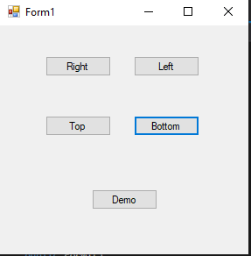

Activity 9

using System;

using System.Collections.Generic;

using System.ComponentModel;

using System.Data;

using System.Drawing;

using System.Linq;

using System.Text;

using System.Threading.Tasks;

using System.Windows.Forms;

namespace Calculator

{

public partial class Form1 : Form

{

public Form1()

{

InitializeComponent();

}

private void label2_Click(object sender, EventArgs e)

{

}

private void btnMultiply_Click(object sender, EventArgs e)

{

FirstValue = Convert.ToInt32(this.textBox1.Text);

SecondValue = Convert.ToInt32(this.textBox2.Text);

this. txtResult.Text = " " + (FirstValue * SecondValue);

}

private void btnAdd_Click(object sender, EventArgs e)

{

FirstValue = Convert.ToInt32(this.textBox1.Text);

SecondValue = Convert.ToInt32(this.textBox2.Text);

txtResult.Text = " " + (FirstValue + SecondValue);

}

private void btnSubtract_Click(object sender, EventArgs e)

{

FirstValue = Convert.ToInt32(this.textBox1.Text);

SecondValue = Convert.ToInt32(this.textBox2.Text);

txtResult.Text = " " + (FirstValue - SecondValue);

}

private void btnDivide_Click(object sender, EventArgs e)

{

FirstValue = Convert.ToInt32(this.textBox1.Text);

SecondValue = Convert.ToInt32(this.textBox2.Text);

txtResult.Text = " " + (FirstValue / SecondValue);

}

}

}

Output

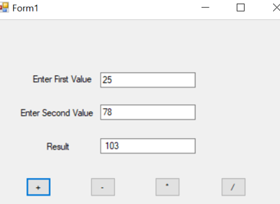

Activity 10

1. Create a new project named HangmanGame.

2. Add following controls on form

|  |  |  |
| --- | --- | --- |
| Control | Set following properties | Events |
| Label1 | Guess a Letter! |  |
| Label2 | Guessed Letters: |  |
| Label3 | Guesses Left |  |
| Label4 | (A random name with random spaces) |  |
| TextBox1 | 1. Name = GuessBox 2. MaxLength = 1 |  |
| Button1 | 1. Name = btnGuess 2. Text = “Guess Letter!” | btnGuess_click() |
| PictureBox1 | 1. Name = picGuess |  |

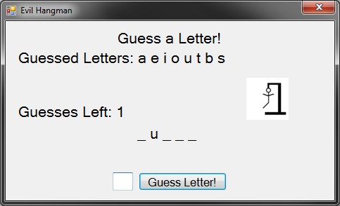

3. Use following steps to add images to the PictureBox

4. Drag and drop PictureBox on the form1.

5. Click on the play button to open a context menu.

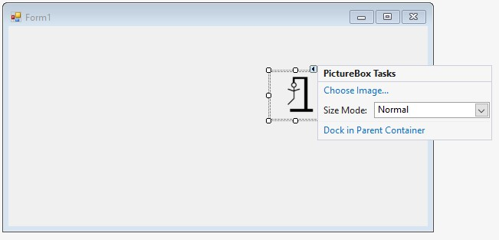

1. Click choose Image
2. On the new popup go for the Import Image from local resource

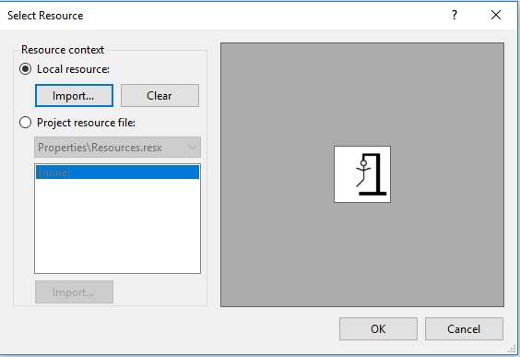

1. Click ok and the image will be imported in the selected PictureBox.

Output

